The Newsletter for Middleton on the Wolds

Issue No 18

August 2020

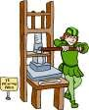
NEXT COPY DATE
14th August

Please send in your contributions to middletonflyer@yahoo.com by the end of the copy day. If I don’t acknowledge them please get in touch to make sure they have arrived.
As you know we are always trying to make the
Messenger an interesting magazine for the people of the Middleton to read and enjoy but we need YOU to send in articles, recipes, anecdotes, quizzes etc to fulfil this.
Do you remember Pat’s banana cake recipe from a few months ago? I have found it makes great muffins especially with the addition of mixed spice, dates and walnuts. They freeze easily and can be thawed in seconds in the microwave when you fancy one with coffee. Has anyone else a quick recipe that we can put in for September?
Local Clubs
I hope that next month we will be able to extend the “Regular Group Activities” on the back page as groups restart so please let me know by 14th.
Lyn
If you have any ideas, comments or complaints (especially complaints) you want to share then send an email to middletonflyer@yahoo.com.
Remember, we can’t respond unless we receive your message.
The front cover photograph was taken by Hazel Kazer along the embankment.

editorial
And so it continues. I’ve got to admit that, even for someone as naturally lazy as me, this enforced inactivity is getting a bit tedious. On the other hand, I would prefer to be simply bored to death’ than suffer the alternative after being attached to a ventilator so I have no plans to head for Bournemouth in the near future!
Anyway, lockdown has been relaxed. You can get your hair cut, go out for a meal – and the pub’s open! Given the number of caravans and motorhomes going up and down Front Street the campsites are open, too. Many people have been seriously affected by their enforced isolation and being now able to get out must be a very welcome development. As long as we all use a bit of common sense. Remember, the government hasn’t eased the rules because we’ve beaten COVID 19, they’ve done it to help businesses and to give a boost to the economy. So be careful out there, kids! Keep your distance from others and wash your hands often.
The Prime Minister has just announced the compulsory wearing of face masks in shops and I know the jury is still out on whether or not they are effective. There is still some uncertainty about how the virus is passed from one person to another but being carried in coughs and sneezes is a strong contender. The strongest argument I’ve seen for wearing a mask is that, even though the virus may be smaller than the weave of the mask, the water droplet isn’t and can be stopped from escaping. Which means that the wearer has less chance of infecting someone else and, as we’ve all already done what we can to slow down the spread of the virus, doesn’t it make sense to do this as well?
The increased activity on the roads has reminded us all of the perennial problems we have with traffic going through the village, be it wide loads, speeding, or not being able to cross Front Street. Elsewhere in this newsletter the Parish Council is asking for your views to help ‘encourage’ the county council to take some action. It is in your best interests to support the PC in this so please let them know what you think.
The other thing you can contact the PC about is fly tipping. It’s still happening and if you have any idea of who might be doing it then let someone know. Think of it not so much as grassing someone up and more of stopping someone treating your home as a skip.
Stay safe.
Cheers, Mike
St Andrew’S church

GREAT NEWS
At long last St. Andrews church will open for public worship at 10.30a.m. on Sunday 9th.August.
Our Vicar, Jane will lead the service.
For the rest of August here is the rota :-
Sunday16th.August.Morning prayers at 10.30.a.m.Rev. Canon Kate Goulder.
Sunday 23rd August. Morning prayers at 10.30.a.m. Rev.Ruth Newton.
Sunday 30th. August.TBA, but probably a Benefice service.

All the requirements for hygiene and social distancing will be observed.
All will be welcome at St. Andrews for these services.
The wolds METHODIST CHURCH bainton
The chapel is still closed until further notice.
Hopefully there will be more positive news for you next month.

QUIZ PAGE
- Name the 'Super Hero' - Doctor Banner?
- To the nearest billion what is the population of planet Earth?
In California, you cannot take a picture of a man with a wooden leg. 3
Why not?
- How many stars are on the European Union flag?
- In Downton Abbey Violet Crawley is played by who?
- Angel Falls is in which country?
- Which sweet treat could be found at the Ambassador's parties?
- 2013 Crime Drama starring David Tennant as DI Alec Hardy?
- In Monopoly which is the only property south of the River Thames?
- TV Comedy Terry and June, starred Terry Scott and June who?
Quiz set by Rowland Wooldridge
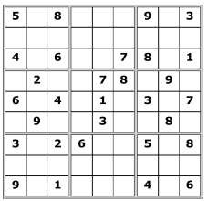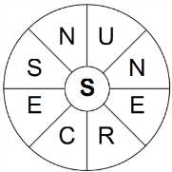

SAYINGS DINGBATS

SUDOKU

All answers on page 16

WORD WHEEL

This Summer themed word wheel is
made from a 9 letter Summer themed
word. Try and find that word, then
make as many words of any length as
you can from these letters. You can
only use each letter once, and each
word must include the letter

S
.

A note from your vicar
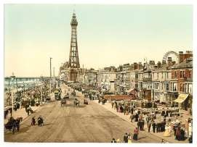
Do you remember Wakes Week?
In 601 AD Pope Gregory wrote a letter of instruction to the missionaries he had dispatched to convert the ‘heathen’ Anglo Saxons on these Isles (the fact that Celtic Christianity thrived here seems to have been neither here nor there to the Pontiff!) He directed them not to destroy the sacred buildings
which already existed as shrines for the pagans but instead to sprinkle them with holy water, set up altars and relics of the saints and encourage the people to celebrate a religious and solemn festival where they could eat the meat they had once offered to their gods. Each church was to be consecrated to a Christian saint – this Patrons feast day would be marked with a special service. The services began at sunset on Saturday with prayers throughout the night – this vigil was called a Wake (presumably because you had to stay awake when you would normally be asleep) the following morning there would be a special festival service followed by sports, games, eating and drinking. However, the Popes idea of sedate fellowship was not quite what those naughty Anglo Saxons had in mind! And much revelry took place, so much so that the service and fellowship were separated over time.
During the Industrial Revolution the tradition of time to enjoy yourself away from the hard and relentless day to day working life became a regular summer holiday especially in the North of England and parts of the Midlands. It was also, over time, extended to a whole week. This was an unpaid week off work, giving the mills, collieries and other industries time for maintenance to the machinery.
Each area nominated a Wakes Week when everyone – from weavers, mill workers, and pit men would go away – usually to the sea side as there was a great belief that ‘taking the air’ was good for you, and it is no surprise when you think about the stifling, life threatening conditions most of the people had to endure for the rest of the year. Blackpool became a very popular seaside resort especially for Lancashire Mill and industrial workers, with Southport being a bit more up market while Morecambe attracted workers from the West Riding textile towns.
When I was growing up, I remember my dad, who was then a Centre Lathe Turner in the steel industry, working as much overtime as he could in the two weeks leading up to Wakes Week (usually last week in July or the first week in August) These weeks were called ‘Bull Weeks’ when you worked as hard as a bull to earn a bit extra to pay for your holiday.
Samuel Laycock was a vernacular poet, born in 1826 who documented the lives of Lancashire cotton workers. He was actually born in Marsden, West Yorkshire where his dad was a weaver.
Here are a few verses from his poem ‘We’re having a grand time at Blackpool’.
Eh! We’re havin a grand time at Blackpool;
You’re missin it, you that’s away;
If you’ve got any brass in your pocket, Buy a ticket an come here to-day.

We go down on th Prom – every mornin;
To th grand entertainments at neet, An between whiles we’re eytin an drinkin; An enjoyin oursel’s just a treat.

It beats weyvin, an spinnin, an warpin;
Does this jod, so just yo come deawn; I wouldn’t have missed th fun we’re havin; No, not if I’d spent th last hauve- creawn.

Ay! We’re havin a rare time at Blackpool,
An we’re sorry for yo that’s away
So, if you’ve five bob in your pocket Buy a ticket an come here to-day.

Whatever you are doing this summer, ‘stay-cation’ or going away, I hope you have a good break and return refreshed.

Jane

Yorkshire Countrywomen’s Association Middleton-on the-Wolds Branch News
WE ARE PLEASED TO ANNOUNCE THAT MEETINGS ARE BACK FOR AUGUST…..
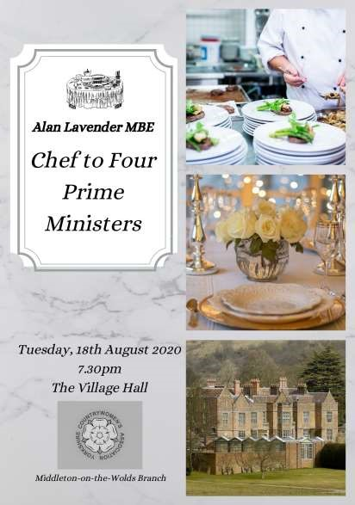
………….AND SEPTEMBER! ON TUESDAYS IN THE VILLAGE HALL
Further information from: Christine Johnson 01377 217374
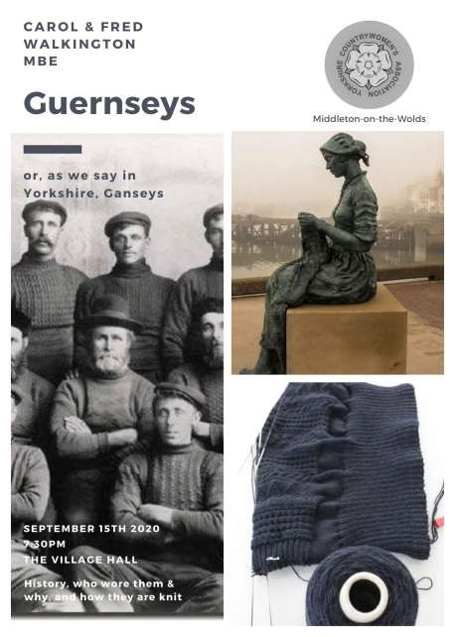

Parish council
The Parish Council now has 2 vacancies for Councillors, and anyone who feels they would like to apply and that they could help bring new ideas and support the needs of the village should contact the Parish Clerk either in writing or email. Alternatively please feel free to approach any member of the Parish Council for further information.
The play area on Orchard Drive is now open again; however we have been given guidance relating to Covid-19 rules and these will be displayed at the entrance, and we request these rules are followed and would suggest children are supervised by their parents or responsible adults.
The play equipment at the playing fields is still closed as this equipment is awaiting refurbishment; we therefore request the equipment is not used.
Some residents are having difficulties finding space to park near the Post Office / Hair Dressers and the Reading Rooms. We would therefore request that residents consider others when parking here and avoid overnight parking, unless you live in the houses in the properties adjacent to the two parking bays.
John Eastwood Chairman

The Parish Council is putting a case together demonstrating the impact traffic is having on the quality of people’s lives putting a strong emphasis on safety for residents. First hand experiences will help this case immensely so, if you have been or are being affected by traffic issues, especially relating to Front Street and Station Road, please let the Parish Council know.
Mike Kelly
Parish Councillor

Community Plan Updates
TRAFFIC-Front Street traffic appears to be returning to near normal and with it both speed and associated pollution. Parish Councillors are to meet with the Humberside Police Speed Watch Coordinator and conduct a village site visit and to discuss how to carry out speed monitoring. Watch this space for volunteering opportunities to assist in this project. Once group meetings are allowed again the Parish Council will discuss other options such as Pelican Crossings with Local Authority Councillors.
PLAY AREA- The Coronavirus Outbreak has meant that the survey has not been possible to be collected from peoples homes and so will be relaunched in the Autumn.
GREEN ISSUES- Great to see all the clearing work that is being undertaken on the Railway Line, it’s coming on brilliantly and thanks to all involved.
Next Stop the other bank on Station Road? Wouldn’t it be great if we all got together to help clear it and make it accessible again?
TRANSPORT- The Parish Council has submitted a letter of support for a Rural Transport funding proposal to increase services to and from the village.
LITTER- Following recent incidences of littering including that of clinical waste Parish Council Members have met with EYRC to raise awareness of the problems. They have the power to issues fixed penalty fines of £60 to offenders and encourage residents to keep an eye out for offenders. Incidents can be reported direct to them or via the Parish Council, contact Nick Jones nj@motwparishcouncil.co.uk.
Following a site meeting, in the coming weeks EYRC are to install a fixed Green Bin with a restricted latch opening on the bend up Beverley Road where the road meets the Public Footpath. This bin can be used for all types of small items of waste including bagged dog excrement. Hopefully this will stop littering in this area. Please use and encourage others to use this facility!
Cheers
Nick Jones
Parish Councillor
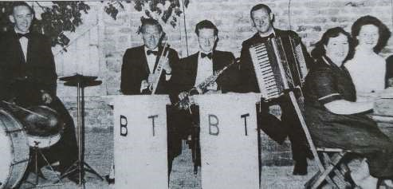
Above is a photo from The Driffield Times which relates to some of the people mentioned in the Local History page last month.
Left to right: Billy Thompson, Fred Robson, Alan Iveson, Geoff Lidster, Audrey and Hazel.

LOCAL HISTORY
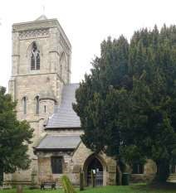
ST. ANDREWS CHURCH – A BRIEF OUTLINE HISTORY
Although Christianity of sorts had been present in Britain during the Roman period with Bishop Eborius of York attending the Council of Arles in AD 312 the defining moment in East Yorkshire according to tradition was the conversion of King Edwin to the faith followed with the destruction of the pagan temple at Goodmanham by the high priest Coifi in 627. The subsequent conversion of the Wolds area to the new beliefs, said to be by missionary priests from Hexham in the following decades, was a
process eased by the retention of certain pagan beliefs and practices which, when added to the mystery of the mass, helped to incorporate and legitimize the world of superstition ever present in this early period and for centuries to come.
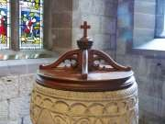
The Domesday Book of the 1080s refers to a church and priest in Middleton but the building would probably have been a primitive structure of wattle and daub constructed on the orders of the local chieftain when the village began to emerge from a scattered settlement in the late Saxon period.
In the two centuries after the Norman conquest in
1066 and the following years of unrest more
substantial churches gradually appeared throughout the East Riding. In Middleton the building of the church developed in stages in the thirteenth century on an elevated site in the traditional style for Christian churches with the congregation looking towards the east and two highly prized features of the building throughout the centuries have been the “Noble” chancel and the Norman font. John de Sculcoates, appointed in 1236, was the first in a long list of Rectors who played an important part in village life.
In the pre-reformation days colourful church interiors could help the priest,
armed with his Latin Bible, explain the Christian message to the largely illiterate congregation but in the turbulent years following the Reformation in the 16th century and the Civil Wars in the 17th we can only guess what desecration may have taken place in the church interior. Things settled down however and if anything religious practice in the Established church became more somnolent before being enlivened with the arrival of Methodism by which time the King James Bible, for many the ultimate English translation of the text, had become one of the nation’s most cherished books.
A description of the church in Allen’s History of Yorkshire in 1831 says that the building was in good preservation and intriguingly adds “On the west end of the roof is a neat little octagonal turret, having a dwarf spire, with pinnacles etc. all of modern workmanship”. However in 1865 Sir Stephen Glynne M.P., the brother in law of the Victorian Prime Minister William Gladstone and an eccentric visitor of churches, refers to a replacement stone tower of 1830 of “ poor modern work.”
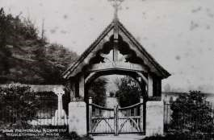
In 1873 “The Hull Packet” newspaper painted an unappealing picture of the church’s state. “For a long time the condition of the sacred edifice was the source of much regret to the parishioners, the walls being in so crumbling condition and the tower so dilapidated that it can scarcely have been seen to have been
watertight” So it was time for a thoroughly high minded Victorian makeover which was carried out by J. M. Teale of Doncaster after which the newspaper report reads “Instead of the dingy barn-like appearance the old church has presented for years we now have a structure of an elegant open aspect.” At last there was a sturdily constructed tower to give the church more presence although at a later date the Pevsner guide sums up the renovated building by declaring that “There is hardly anything telling that is not Victorian.”
In 1904 the churchyard was closed for new burials and the present cemetery opened, eventually with the inscribed lychgate serving as a memorial to the village’s First World War dead.
As with most places of worship Middleton Church has had its share of structural and financial problems and these things together with the threat of burglaries are an ever present concern. To conclude this brief outline it is as well to mention that over the years there have been long periods when the bells, an intrinsic part of the church fabric, were silent and then restored. John Goodrick, a former headmaster of Middleton School, took an active interest in this. One such restoration occurred in 1972 and was wecomed by Ted Dooks, a retired railway man,who had taught many villagers to handle them. Geoff Wisher

Village hall news
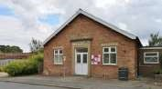
By the beginning of August we expect that the flat roof at the side of the Village Hall will have been replaced, thanks to a grant from The FCC Communities Foundation Ltd.
We will take the next week or so to get the hall equipped with the safety equipment, sanitisers and signage required to be COVID-19 compliant.
The Village Hall will be ready for use from Monday 11th August and we look forward to welcoming back our regular classes and hirers when they feel ready. Obviously there will be government instructions to follow regarding social distancing, regular hand washing and hand gelling etc but we will be issuing guidelines to all hirers.
One main difference from 11th August is that we will be putting in place a one way system with entry via the side fire doors and exit via the front doors. This should avoid a bottleneck in the entrance hall near the toilets. And, mentioning the toilets, only one person at a time is to be in the ladies and one in the gents but the disabled toilet will also be in use.
If you would like to hire the hall for a private function please get in touch with me on lyndennis456@gmail.com
Lyn Dennis
The Village Hall Committee

Middleton book group

Book review for Middleton Book Group – 16th July 2020
No tea and cakes at the moment but it’s good to get together over zoom to chat and compare notes on the month’s chosen books and other reading we’ve chosen this month and the ways we are tackling the Covid19 restrictions.

“Regeneration”
“Regeneration” is the first book in a trilogy by Pat Barker about horror of the 1st World War. The main protagonist is
William Rivers – a psychiatrist treating shell shocked soldiers and working towards a better understanding of the way to treat it. At Craiglockhart in Scotland, he meets and treats Wilfred Owen and Siegfried Sassoon. Rivers’ job is to prepare the men to return to the battlefield but it becomes a harder and harder decision for him to make – to send them back to the front. As their stay at Craiglockhart continues, Owen and Sasson become friends.

“66 Years a Cycle Tourist”

Written by Cliff Pratt – a well known cycle dealer in Hull, this is an autobiography of a life of working and enjoying cycling in this country and all over the world. It is a fascinating insight into the world before and after the 2nd. World War. Cliff loved photography and film making and the book includes some of his photographs and cartoons drawn by his elder brother who was a commercial artist during those years.

June

Next books for discussion:
“The House Share” by Kate Helm
“The Silence Before Thunder” by Kathy Shuker

To find out more about the Book Group please contact Lyn on 219500 or lyndennis456@gmail.com

Local Birds & wildlife
Last month when I was looking out at the garden while I was typing there was constant activity (and noise) out there – it was difficult to concentrate! Today, though, it all seems rather quiet. The fledglings have reluctantly let go of their parents’ apron strings and spread out to find their own patches, recent cooler temperatures and rain have cut down the numbers and varieties of butterflies around and while the vole is still making the odd appearance, the
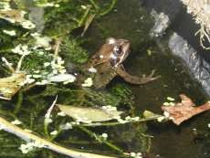
The wet conditions delivered a frog to the garden – something we’ve not seen for a while. It was sitting in a small log pile next to the fire pit – not an ideal place for a frog to set up home. Hazel has more sensible frogs that visit their pond and one of which turned up again this week; there was frogspawn in the spring, but voracious fish hoovered it up. (Did you know that robins eat tadpoles? While nature hasn’t equipped them for diving and hunting them underwater, I have seen one gobbling up as many as he could when a tadpole-transferring operation left some wriggling on the ground). The current frogs look like last year’s survivors; not quite full-sized but too big to be from this year’s brood.
shrew seems to have gone off in a huff.

I was hoping that the rain would bring out the slugs (sorry keen gardeners!) so that our camera trap would once again catch hedgehogs bustling around the garden, but we seem to have just one turning up in the early hours and not spending too long here. Pat, however, has been having a much more exciting time: “…..put the hedgehog food down and we have a family of 3 eating it up. Big one, middle one and now a baby charging round like a mad thing. They’re here every night. We think they’re living under my shed. Thrilled to bits!”
In June I suggested keeping an eye out for the white-tailed eagles seen on our coast – bit of a long shot, but you never know – and now bird-watchers in Derbyshire have been treated to a lammergeier, or bearded vulture, an even bigger bird! Well, it is very close to South Yorkshire, and who knows if it might eventually cut across East Yorkshire on it’s way back to the continent? There was a black-browed albatross in Bempton recently and a few years ago Ian saw a huge black bird being mobbed by rooks which seemed beside themselves with panic (or rage!) and later saw a report of a 1st-year gannet which for some reason had headed away from the sea and was in the area, which seemed to fit the bill (boom boom! Sorry).
Lastly, an odd bit of behaviour in our garden – a noisy kerfuffle between a female blackbird and a wood pigeon. Lots of posturing and then the blackbird chased the pigeon away, flying off hot on it’s heels. Then about 20 minutes later, the same thing again, with the blackbird again the victor. Had it been following the pigeon all that time, or did it just meet up with it’s arch-enemy again?
If you have any interesting sightings, photos, or odd behaviour to report please get in touch at lavenderbarbara97@gmail.com or phone/text 0777 192 7868
Barbara
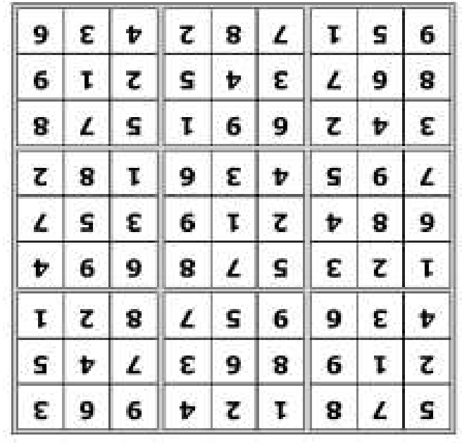
Quiz answers

Dingbats:

Full of cold

High blood pressure

Cough mixture

Nil by mouth

Chicken pox

1

The Incredible Hulk

2

Seven

3

You can't take pictures
with a wooden leg

4

12

5

Maggie Smith

6

Venezuela

7

Ferraro Rocher

8

Broadchurch

9

The Old Kent Road

10

Whitfield

Word Wheel:

Sunscreen

Middleton on the wolds ce ve school
Executive Headteacher: Mrs E Harros
Station Road, Middleton on the Wolds, Driffield YO25 9UQ
E-mail:middleton.primary@eastriding.gov.uk Tel: 01377 217323

Clothing Collection
If you are having a clear out during the summer, please remember that our next ‘Bag2school’ clothing collection will be on Monday 28th September. Any unwanted clothes, shoes, handbags, hats, scarves,
jewellery, belts or cuddly toys can go in the collection. The heavier the collection, the more money that is raised for school, so please save all unwanted items for us. Bags must be in the school car park by 9am on Monday 28th September.

Middleton Minis
Following Government guidance, Middleton Minis will not be running for at least the first half term. Please look out in future newsletters for a re-opening date.

On-going Collections
On-going Collections – We collect used stamps, used batteries, old mobile phones and used printer cartridges. Thank you.

Middleton on the Wolds Nursery
At Middleton on the Wolds CE (VC) Primary School
Providing education for 2, 3 and 4 year olds Monday - Friday.
We accept the Government’s childcare vouchers for up to 30 hours of free provision for 3 year olds (conditions apply)
Additional sessions can be purchased for £13.50 per session for 3 year olds and £15.75 for 2 year olds.
Lunchtime sessions are £1.75 (free if children attend for the whole day) with the option to purchase a school meal for £2.40.
Children are welcome in the term after their 3rd birthday for funded places.
For further details, please contact: Sharon Stone
Email: middleton.primary@eastriding.gov.uk Tel: 01377 217323

End of Term
School closes on Friday 17th July and reopens at 08:40 am on Tuesday 8th September.

Messenger correspondence
The Lighter Side
I let Whiskey the dog out last night through the back door for a wee. There was a large hedgehog just by the door step.
Whiskey originally ran past it and then noticed it so whipped round growling and sniffing. The hedgehog then simply looked at him so 'brave' Whiskey backed up but too far and his back legs went over the edge of the patio. So Whiskey now is effectively 2 legged and, in his world, was facing a 'vicious' snarling hedgehog with the option to either plummet down on to the decking or to be eaten alive by a 'huge' predator. He instinctively tried to drag his backend back on to the patio thus contradictorily bringing him closer and closer to his nemesis. However, his newly cut nails could not gain traction on the slate so his front legs galloped faster and faster but his backside outweighed the advantage the scrambling front legs were trying to make.
The dog now glanced at me and his eyes asked me to sort the conundrum of either being torn limb from limb by an animal that has successfully survived from prehistoric times by eating Westies, OR plummeting to his death by falling 3 foot down to the cruel decking below. By this time I was laughing so much, and having had a drink or 2 myself, I needed to go to the loo. I calculated that Whiskey had only a few seconds left before gravity and his not so small backside won the ageless tussle between two forms of ignominious death. So I picked him up and went in. Such things make life worthwhile.
Geoff Cox
One of St Andrews church bells will be rung at 11:10 am on 15th August to mark VJ day 75 years ago.
Chris Atkin
Advertising Feature

Advertisement
Advertising Feature
Regular group activities
The Village Hall
From Monday 11th August 6.00pm Pilates will be resuming
Tuesday 18th August 7.30pm Yorkshire Countrywomen’s Association
 | LOCAL CONTACTS Bell Ringing Chris Atkin |  | 217285
 | Book Group/Middleton Movers | Lyn Dennis | 219500
 | Bowls Club | Rob Bradley | 217435
 | Country Women’s Association | Christine Johnson | 217374
 | First Responders | Chris Brent | 219469
 | Line Dancing | Pat Pottage | 217516
 | Methodist Chapel | Miss P Hodgson | 217426
 | Middleton Messenger | Mike Kelly | 07713 620912
 |  | Lyn Dennis | 219500
 |  | Tina Walker | 217242
 | Middleton Womblers | Andrew Naylor | 219072
 | Parish Clerk | Sandra Morrison | 01262 470496
 | Reading Rooms | Kath Bentley | 217456
 | Recreation Club | Dave Newlove | 07901 833784
 | St Andrew’s Church | Rev Jane Anderson | 219471
 | St Andrew’s Church Warden | Roger Lowe | 217656
 | Table Tennis | Louise Newlove | 217801
 | Village Hall Lyn Dennis |  | 219500
ADVERTISING COSTS for the Messenger
Rates Month Year

Whole Page £25 £150

1/2 Page £15 £100

1/3 Page £10 £60
Full colour - Print run 500 copies
Contact: Tina 01377 217242, middletonflyer@yahoo.com

